 | 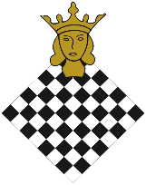 | 
1st Pia Cramling Cup during Rilton
The FIDE Commission for Women’s Chess and the Stockholm Chess Federation invite you to the inaugural Pia Cramling Cup, held during the Rilton Cup for girls and women.

Date: January 2, 2026

Venue: Scandic Continental, Vasagatan 22, 3rd floor

Format: The FIDE rated (rapid) tournament will be held using the Swiss system over seven rounds in accordance with the FIDE Laws of Chess.
If two or more players finish with the same number of points, the prizes will not be shared; final standings will be determined according to the tie-break criteria. Tie-break order: 1. Buchholz, 2. Direct encounter, 3. Number of games won, 4. Number of games played with Black

Time control: 8 minutes+4 seconds/move

Schedule: | 1 | 10:00 | 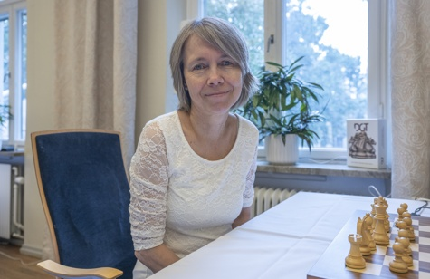  Photo: Lars OA Hedlund
 | 2 | 10:30
 | 3 | 11:00
 | 4 | 11:30
 | 5 | 12:00
 | 6 | 12:30
 | 7 | 13:00
Check-in: Inside the playing hall until 9:45

Start fee: Free

Registration: member.schack.se/turnering/6248/anmalan

Players: 1st Pia Cramling Cup

Prizes: Sponsored by the FIDE Commission of Women’s Chess, DGT, and Majana.

 | 

